**CENTRAL BANK**

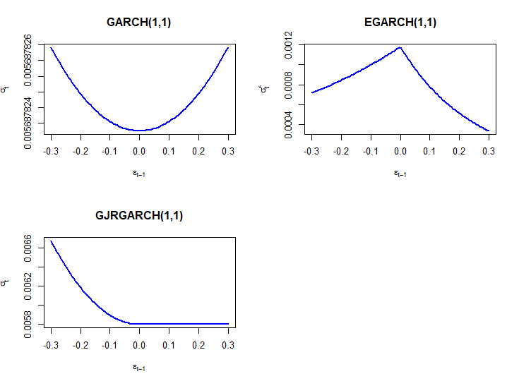

* From news impact curve of GARCH (1, 1) we observe that the positive andnegativeshockshavesameeffectonvolatilitybecauseitdependsonthesquareof the previous shocks.
* EGARCH(1,1) and GJRGARCH(1,1): Both show asymmetrical impacts, with EGARCH emphasizing a stronger response to positive shocks and GJRGARCH highlighting a more significant response to negative shocks.

**KARNATAKA BANK**

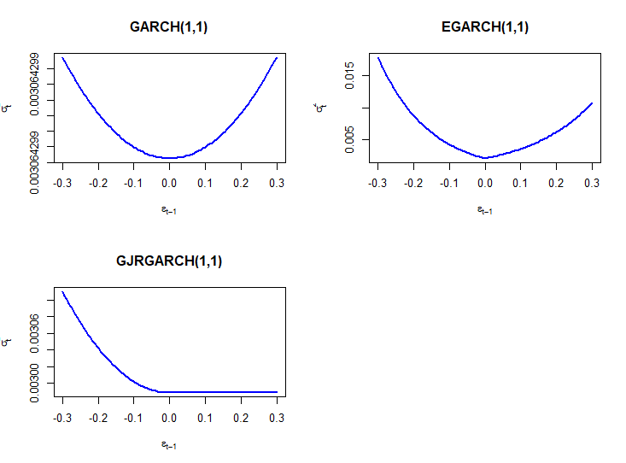

• The GARCH(1,1) model presents a symmetrical news impact curve, indicating that both positive and negative shocks have an equal effect on future volatility.

• The EGARCH(1,1) model shows a slightly asymmetrical news impact curve, suggesting that negative shocks have a marginally greater impact on future volatility compared to positive shocks of the same magnitude.

• The GJR-GARCH(1,1) model exhibits a pronounced asymmetric news impact curve, with negative shocks having a significantly larger effect on future volatility than positive shocks.

# **DCB BANK**

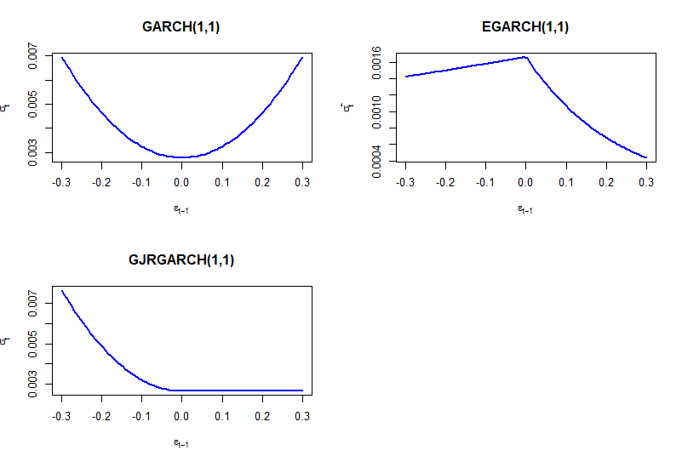

• The GARCH(1,1) model presents a symmetrical news impact curve, indicating that both positive and negative shocks have an equal effect on future volatility.

• The EGARCH(1,1) model shows a slightly asymmetrical news impact curve, suggesting that negative shocks have a marginally greater impact on future volatility compared to positive shocks of the same magnitude.

• The GJR-GARCH(1,1) model exhibits a pronounced asymmetric news impact curve, with negative shocks having a significantly larger effect on future volatility than positive shocks.

# **NESTLE**

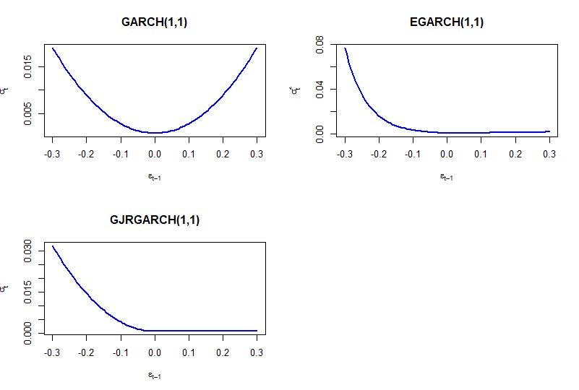

• The GARCH(1,1) model presents a symmetrical news impact curve, indicating that both positive and negative shocks have an equal effect on future volatility.

• The EGARCH(1,1) model shows a slightly asymmetrical news impact curve, suggesting that negative shocks have a marginally greater impact on future volatility compared to positive shocks of the same magnitude.

• The GJR-GARCH(1,1) model exhibits a pronounced asymmetric news impact curve, with negative shocks having a significantly larger effect on future volatility than positive shocks.

ZYDUS

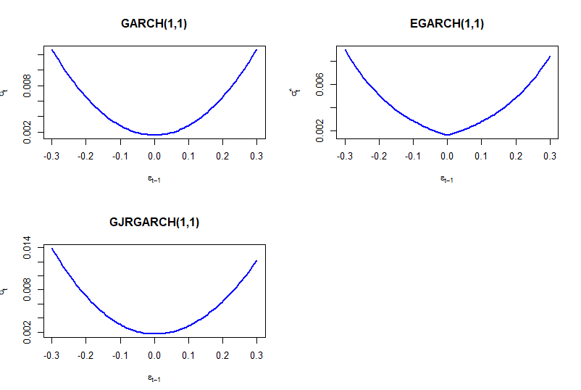

• The GARCH(1,1) model presents a symmetrical news impact curve, indicating that both positive and negative shocks have an equal effect on future volatility.

• The EGARCH(1,1) model shows a slightly asymmetrical news impact curve, suggesting that negative shocks have a marginally greater impact on future volatility compared to positive shocks of the same magnitude.

• The GJR-GARCH(1,1) model exhibits a slight asymmetric news impact curve, with negative shocks having a significantly larger effect on future volatility than positive shocks.

# **TASTY BITE**

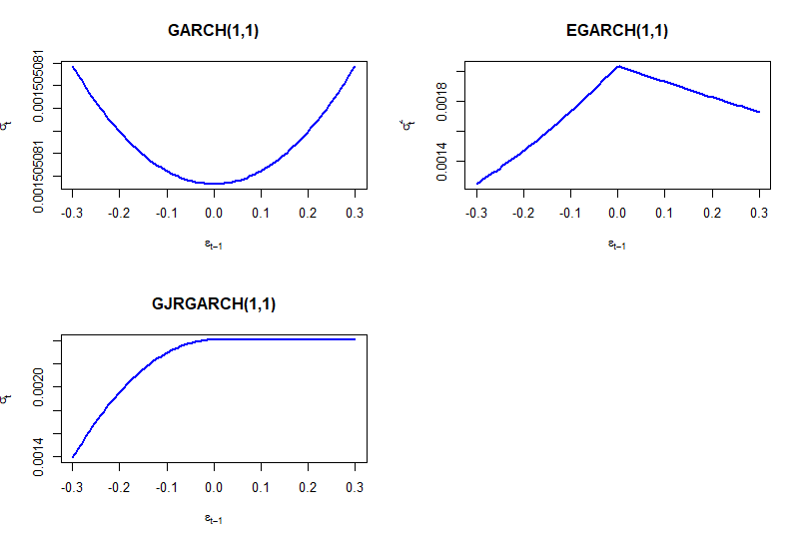

* GARCH(1,1) shows a symmetrical U-shaped curve, indicating equal volatility responses to positive and negative shocks.
* EGARCH(1,1) exhibits a slightly asymmetric curve, suggesting a marginally stronger impact of negative shocks on volatility.
* GJR-GARCH(1,1) demonstrates a pronounced asymmetric curve, clearly showing that negative shocks significantly increase volatility compared to positive shocks.

BHARTI AIRTEL

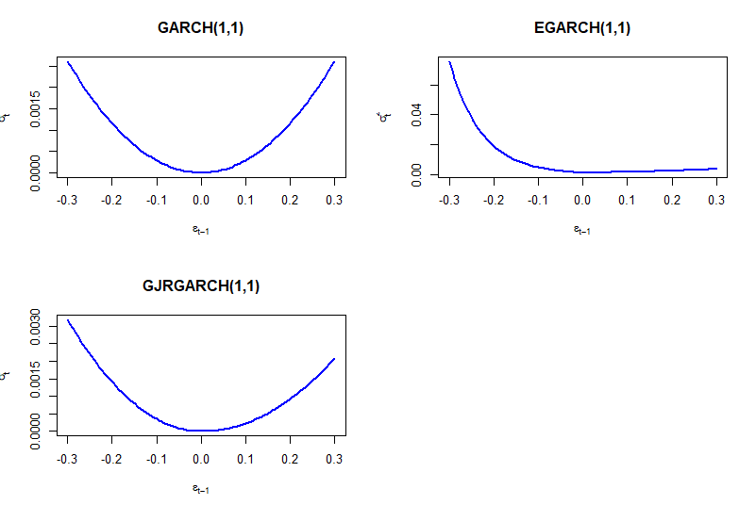

• GARCH(1,1) shows a symmetrical U-shaped curve, indicating equal volatility responses to positive and negative shocks.

• EGARCH(1,1) exhibits a slightly asymmetric curve, suggesting a marginally stronger impact of negative shocks on volatility.

• GJR-GARCH(1,1) demonstrates a pronounced asymmetric curve, clearly showing that negative shocks significantly increase volatility compared to positive shocks

# **HFCL**

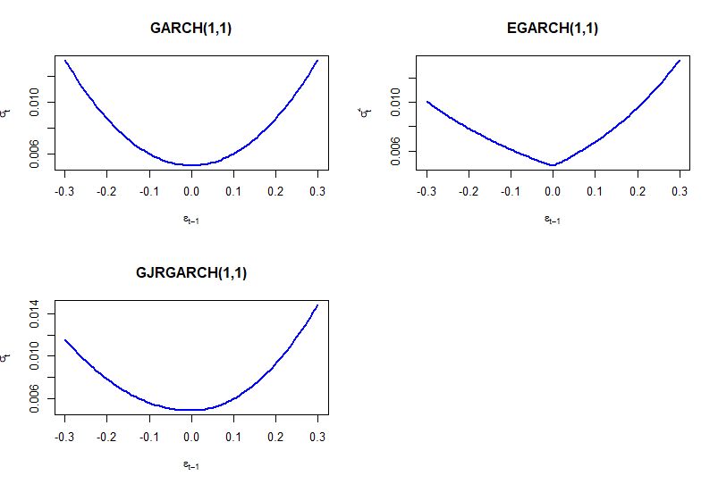

• GARCH(1,1) shows a symmetrical U-shaped curve, indicating equal volatility responses to positive and negative shocks.

• EGARCH(1,1) exhibits a slightly asymmetric curve, suggesting a marginally stronger impact of negative shocks on volatility.

• GJR-GARCH(1,1) demonstrates a pronounced asymmetric curve, clearly showing that negative shocks significantly increase volatility compared to positive shocks

MTNL

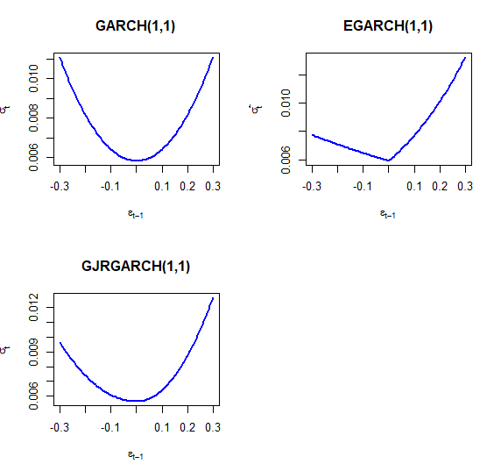

• GARCH(1,1) shows a symmetrical U-shaped curve, indicating equal volatility responses to positive and negative shocks.

• EGARCH(1,1) exhibits a slightly asymmetric curve, suggesting a marginally stronger impact of negative shocks on volatility.

• GJR-GARCH(1,1) demonstrates a pronounced asymmetric curve, clearly showing that negative shocks significantly increase volatility compared to positive shocks

BIRLASOFIT

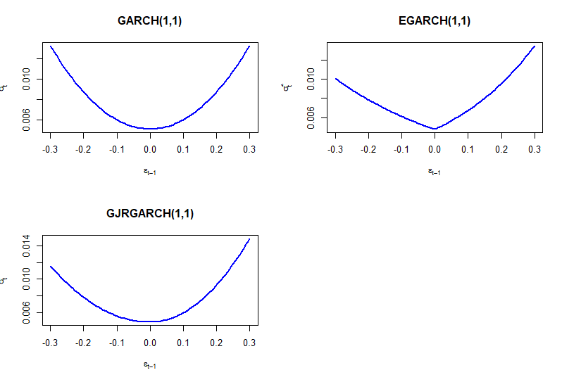

• GARCH(1,1) shows a symmetrical U-shaped curve, indicating equal volatility responses to positive and negative shocks.

• EGARCH(1,1) exhibits a slightly asymmetric curve, suggesting a marginally stronger impact of negative shocks on volatility.

• GJR-GARCH(1,1) demonstrates a pronounced asymmetric curve, clearly showing that negative shocks significantly increase volatility compared to positive shocks

ACCELYA

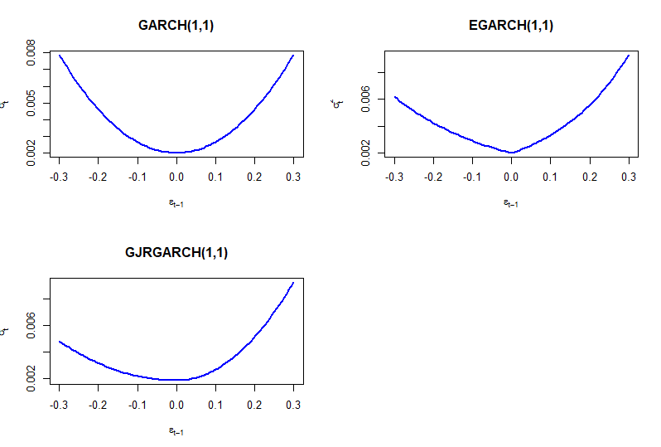

• GARCH(1,1) shows a symmetrical U-shaped curve, indicating equal volatility responses to positive and negative shocks.

• EGARCH(1,1) exhibits a slightly asymmetric curve, suggesting a marginally stronger impact of negative shocks on volatility.

• GJR-GARCH(1,1) demonstrates a pronounced asymmetric curve, clearly showing that negative shocks significantly increase volatility compared to positive shocks

TITAN

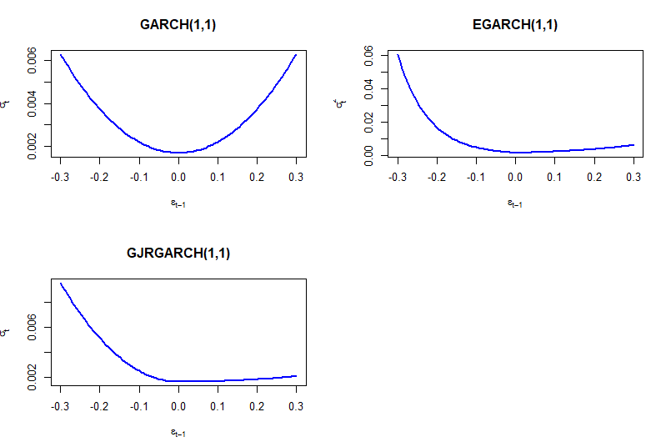

• GARCH(1,1) shows a symmetrical U-shaped curve, indicating equal volatility responses to positive and negative shocks.

• EGARCH(1,1) exhibits a slightly asymmetric curve, suggesting a marginally stronger impact of negative shocks on volatility.

• GJR-GARCH(1,1) demonstrates a pronounced asymmetric curve, clearly showing that negative shocks significantly increase volatility compared to positive shocks

RAJESH GEMS

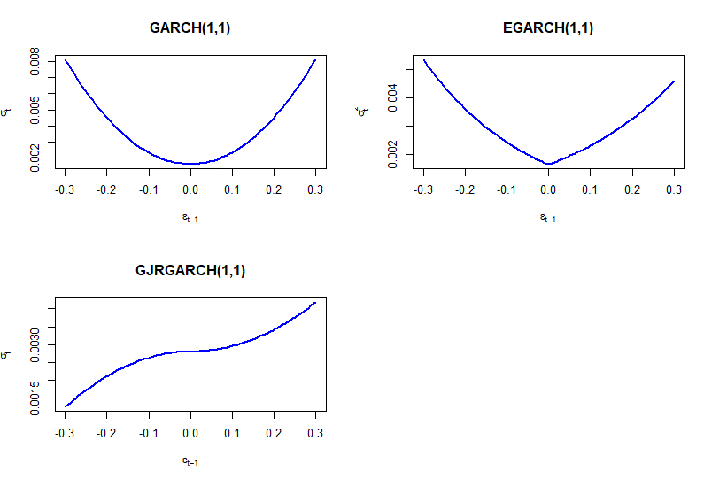

• GARCH(1,1) shows a symmetrical U-shaped curve, indicating equal volatility responses to positive and negative shocks.

• EGARCH(1,1) exhibits a slightly asymmetric curve, suggesting a marginally stronger impact of negative shocks on volatility.

• GJR-GARCH(1,1) demonstrates a pronounced asymmetric curve, clearly showing that negative shocks significantly increase volatility compared to positive shocks

GOENKA

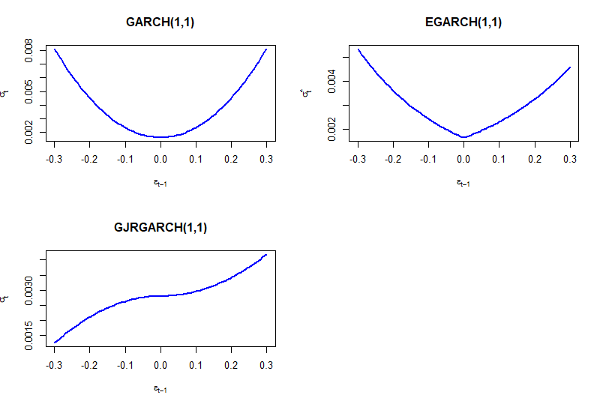

• GARCH(1,1) shows a symmetrical U-shaped curve, indicating equal volatility responses to positive and negative shocks.

• EGARCH(1,1) exhibits a slightly asymmetric curve, suggesting a marginally stronger impact of negative shocks on volatility.

• GJR-GARCH(1,1) demonstrates a pronounced asymmetric curve, clearly showing that negative shocks significantly increase volatility compared to positive shocks